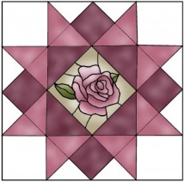
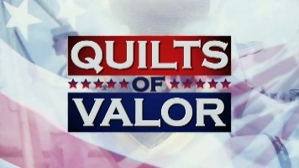
Amador Valley Quilters
Quilt of Valor Nomination

The mission of the Amador Valley Quilters’ Quilts of Valor program is to present Bay Area Veterans
with a Quilt of Valor to honor and thank them for their service to our country. A nomination form must be completed for each recipient and the Veteran must have completed his or her service, been honorably discharged and have not yet received a Quilt of Valor. We are affiliated with the National Quilts of Valor Foundation as a local Quilts of Valor Group, and report our presentations to the national organization. We are not about politics. We are about people.

Please send the completed, signed for to:
Quilts of Valor Amador Valley Quilters P.O. Box 955 Pleasanton, CA 94566

The Quilt is requested for Yourself Someone else This is a surprise Yes No

Recipient information:

Print Name Home ( )

Address Cell ( )

City/St/Zip Email

Branch of Service Army Navy Marines Air Force Coast Guard

Deployment WWII Korea Vietnam Beirut Latin America Iraq Afghanistan

Other

Please tell us about your Veteran. This may be referred to during the presentation.

Your contact information:

Print Name Home ( )

Address Cell ( )

City/St/Zip Email

Signature: Date

Optional – Proposed presentation event name

Date: Time: Location:

Note: Please be advised that photographs of presentations may be used on the Amador Valley Quilters’ website or the Quilts of Valor
Foundation’s website or literature. Your submission grants us permission to do so.
Quilt # Rev Oct 2017
Please visit us online www.amadorvalleyquilters.org www.qovf.org

